**Healthcare Monitoring System**

**SWENG 837**

**Zaid Adam**

**4/27/2024**

**Table of Contents**

**Healthcare Monitoring System** 2

**Problem Statement & Requirements** 2

**Business Requirements** 2

**Non-Functional Requirements** 3

**System Design Using Domain Modeling** 6

**UML Use Case Diagram** 6

**UML Domain Model** 7

**UML Class Diagram** 9

**UML Sequence Diagrams** 10

**UML State Diagram** 12

**UML Activity Diagram (Swimlane Diagram)** 14

**UML Component Diagram** 15

**Cloud Deployment Diagram** 17

**Skeleton Classes & Tables Definition** 19

**Design Patterns** 21

# **Healthcare Monitoring System**

## **Problem Statement & Requirements**

### **Business Requirements**

#### **A. Problem Definition**

The primary problem the Healthcare Monitoring System aims to solve is the lack of real-time health data monitoring and the difficulty in accessing and interpreting this data for both patients and healthcare providers. This system will address the inefficiencies in current health monitoring practices, such as delayed data reporting, limited data accessibility, and poor integration with healthcare decision-making processes.

#### **B. System Functionalities**

The system needs to provide the following functionalities:

1. **Data Collection:** Automatically collect health data from various wearable devices in real-time.
2. **Data Storage:** Securely store large volumes of health data in a cloud-based repository.
3. **Data Analysis:** Analyze the collected data to identify trends, anomalies, and potential health issues.
4. **Alert System:** Generate and send alerts to both patients and healthcare providers if the data indicates potential health risks or deviations from normal patterns.
5. **User Interface:** Offer an intuitive interface for patients to view their own health data and for healthcare providers to access patient data comprehensively.
6. **Reporting Tools:** Provide customizable reporting tools that allow healthcare providers to generate reports based on specific data points and time frames.
7. **Data Privacy and Security:** Ensure robust security measures to protect sensitive health data and comply with health data protection regulations such as HIPAA.

#### **C. Target Users and Their Needs**

The target users of the Healthcare Monitoring System are:

1. **Patients:** Need a simple and intuitive way to monitor their health status, access their health data, and receive timely alerts about their health.
2. **Healthcare Providers:** Require detailed access to patient data to monitor health trends over time, receive alerts about their patients, and use data-driven insights to improve healthcare outcomes.
3. **Healthcare Administrators:** Need tools to manage and oversee the operation of the system, ensuring data accuracy, security, and compliance with regulations.

#### **D. Business Goals**

The system should support the following business goals:

1. **Improve Patient Outcomes:** Enhance the quality of healthcare by providing real-time health monitoring, which can lead to timely medical interventions.
2. **Increase Efficiency:** Reduce the time healthcare providers spend on data collection and analysis, allowing them to focus more on patient care.
3. **Scalability:** Design the system to be scalable to handle increasing amounts of data and users as more healthcare providers and patients adopt the platform.
4. **Compliance and Security:** Ensure the system meets all regulatory requirements for data security and privacy, building trust and avoiding legal issues.
5. **Market Penetration:** Achieve a significant market presence by providing a superior solution that addresses the current gaps in healthcare monitoring.

### **Non-Functional Requirements**

The non-functional requirements are crucial for ensuring that the Healthcare Monitoring System is robust, secure, and capable of meeting the needs of its users while complying with legal and ethical standards.

#### **A. Performance Requirements**

1. **Scalability:** The system must handle increasing loads smoothly, with the capability to support up to 1 million active users and simultaneous data feeds from multiple devices per user.
2. **Response Time:** The user interface for patients and healthcare providers should load within 2 seconds, and data updates should reflect in real-time with no more than a 5-second delay.
3. **Throughput:** The system should be capable of processing at least 10,000 data points per second to ensure timely data analysis and alert generation.

#### **B. Security Requirements**

1. **Authentication:** Implement multi-factor authentication for all users to ensure secure access to the system.
2. **Authorization:** Utilize role-based access controls to ensure users can only access information and functionalities relevant to their role (e.g., patients can only view their own data; healthcare providers can access data of their patients).
3. **Data Encryption:** All data, both at rest and in transit, must be encrypted using industry-standard encryption protocols such as AES-256.
4. **Audit Trails:** Maintain comprehensive logs of all system interactions to support audit requirements and anomaly detection.

#### **C. Maintainability Requirements**

1. **Code Modularity:** The system should be developed using a modular architecture to facilitate easier updates, maintenance, and scalability.
2. **Documentation:** Comprehensive documentation must be maintained for all system components and workflows to aid in future development and troubleshooting.
3. **Testing Strategies:** Implement automated unit, integration, and system testing to ensure high reliability and facilitate continuous integration and deployment practices.

#### **D*.* Additional Non-Functional Requirements**

1. **Reliability:** The system should have an uptime of 99.9%, with failover capabilities to maintain service continuity in case of component failure.
2. **Usability:** Design user interfaces that are intuitive and accessible, conforming to the best practices in user experience (UX) design. The system should be usable by individuals with varying levels of technical proficiency.
3. **Accessibility:** Ensure the system is accessible according to the WCAG 2.1 guidelines, supporting users with disabilities.
4. **Compliance:** Adhere to relevant healthcare regulations, including HIPAA in the United States, GDPR in Europe, and other applicable laws concerning health data and privacy.
5. **Interoperability:** The system should be compatible with various wearable devices and other health systems to ensure seamless data integration and sharing.
6. **Environmental Considerations:** The system should be hosted in environmentally sustainable data centers, focusing on minimizing the carbon footprint and promoting green computing initiatives.

## **System Design Using Domain Modeling**

### **UML Use Case Diagram**

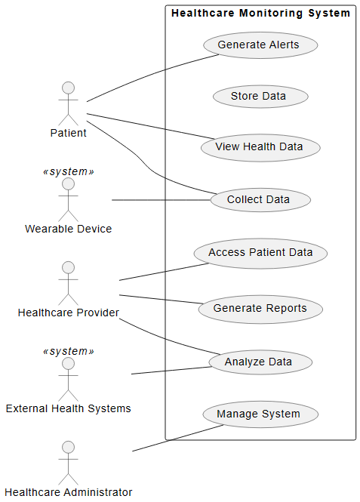

***Figure 1: Use Case Diagram for the System***

#### **Actors involved:**

* **Patients**: Can collect data, view health data, and receive alerts.
* **Healthcare Providers**: Can analyze data, access patient data, and generate reports.
* **Healthcare Administrators**: Manage the system operations.
* **Wearable Devices (System)**: Involved in data collection.
* **External Health Systems (System)**: Engage in data analysis.

The use-case diagram for the Healthcare Monitoring System captures the roles and interactions of various actors with the system's functionalities. Patients, who are primary users, engage with the system by collecting data through wearable devices, viewing their health data, and receiving alerts about their health status. Healthcare providers analyze this data, access detailed patient records, and generate reports that assist in medical decision-making. Healthcare administrators oversee and manage system operations to ensure efficiency and compliance. Additionally, the system interfaces with wearable devices for data collection and external health systems for further data analysis, emphasizing the system's integration and interoperability within a broader healthcare ecosystem.

### **UML Domain Model**

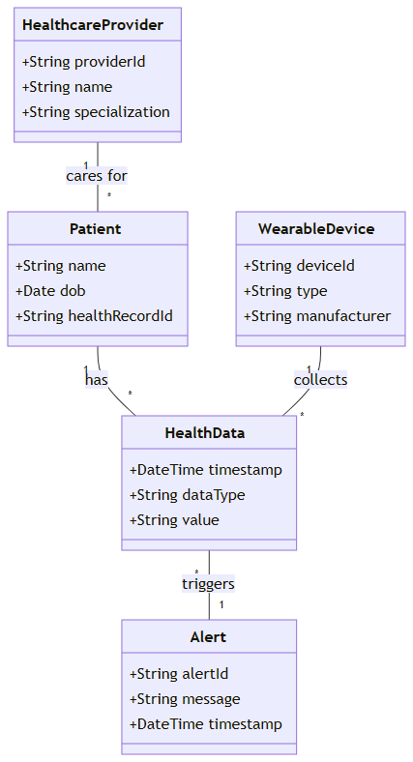

***Figure 2: UML Domain Model***

#### **Key Entities:**

* **Patient**: Holds personal information and has a relationship with health data.
* **Health Data**: Represents various health data points collected over time.
* **Wearable Device**: Devices that collect health data, linked to specific health data entries.
* **Healthcare Provider**: Manages care for patients and has access to patient information.
* **Alert**: Generated from health data under certain conditions, indicating health events or issues.

The UML Domain Model provides a structured representation of the key entities and their relationships within a healthcare monitoring system. The model identifies five primary entities: Patients, Health Data, Wearable Devices, Healthcare Providers, and Alerts. Patients are central to the model, holding personal information and having a direct relationship with their health data, which encompasses various health data points collected over time. Wearable Devices are responsible for the collection of this data, and each device is linked to specific health data entries. Healthcare Providers manage care for patients and can access this information, while Alerts are generated based on the health data under certain conditions to indicate health events or issues. This model effectively lays out the interconnectivity between different components crucial for monitoring and managing patient health.

### **UML Class Diagram**

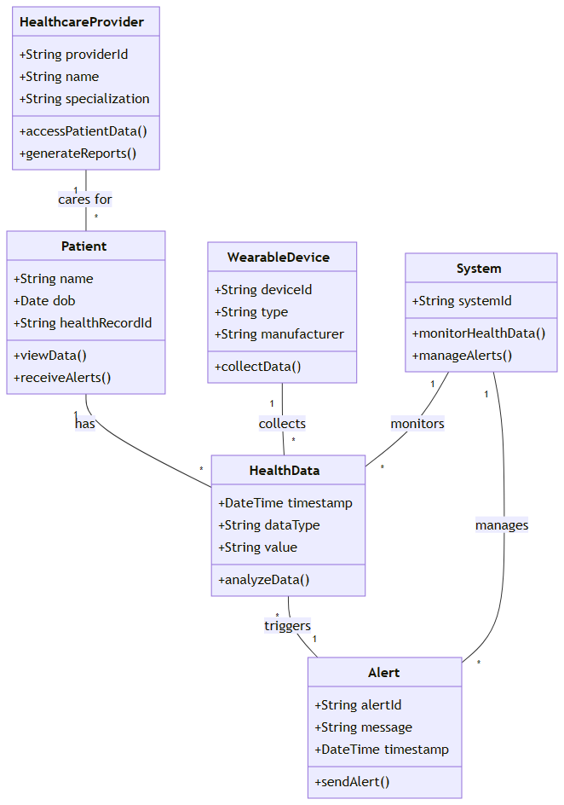

***Figure 3: UML Class Diagram***

#### **Classes and Functionalities:**

* **Patient:** Can view data and receive alerts.
* **Health Data:** Stores data points and includes methods to analyze data.
* **Wearable Device:** Responsible for data collection.
* **Healthcare Provider:** Accesses patient data and generates reports.
* **Alert:** Manages alert generation and sending.
* **System:** Monitors health data and manages alerts.

The UML Class Diagram provides outlines the structure and interactions of classes within the healthcare monitoring system. It defines six main classes: Patient, Health Data, Wearable Device, Healthcare Provider, Alert, and System. The Patient class allows individuals to view their health data and receive alerts. The Health Data class is responsible for storing various data points and includes methods to analyze this data. Wearable Devices are tasked with collecting health data, whereas Healthcare Providers have access to this data and can generate reports. The Alert class manages the generation and dispatch of alerts, and the System class oversees the monitoring of health data and the management of alerts, ensuring that all components function cohesively. This class diagram provides a clear depiction of how different components within the system interact to handle data and alerts effectively.

### **UML Sequence Diagrams**

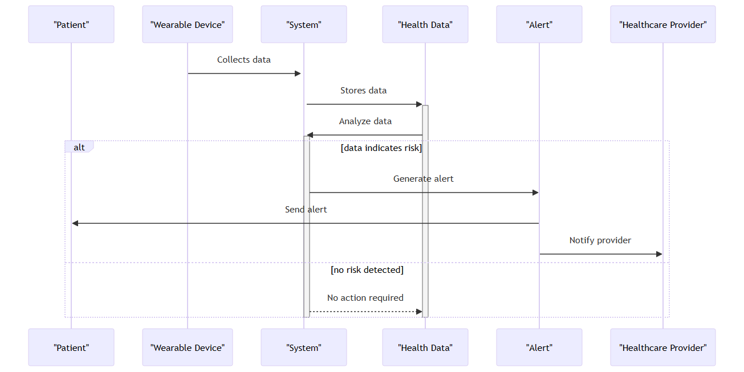

***Figure 4: UML Sequence Diagrams***

#### **Interaction Flow:**

1. **Wearable Device** collects data and sends it to the **System**.
2. **System** stores the data in **Health Data**.
3. **Health Data** is analyzed by the System.
4. If the analysis indicates a risk:
   * **System** generates an alert via the **Alert** class.
   * **Alert** sends a notification to the **Patient** and the **Healthcare Provider**.
5. If no risk is detected:
   * The **System** takes no further action and the process ends.

The UML Sequence Diagrams section of the document illustrates the sequential interactions between various components of the healthcare monitoring system to handle health data. It begins with a Wearable Device collecting health data and sending it to the System. The System then stores this data in the Health Data class, which is responsible for analyzing the data. If the analysis identifies a potential health risk, the System generates an alert through the Alert class, which in turn notifies both the Patient and the Healthcare Provider. If no risk is detected, the System concludes the process without taking further action. This sequence of interactions demonstrates the flow of data from collection to alert generation, emphasizing the system's responsiveness to detected health conditions.

### **UML State Diagram**

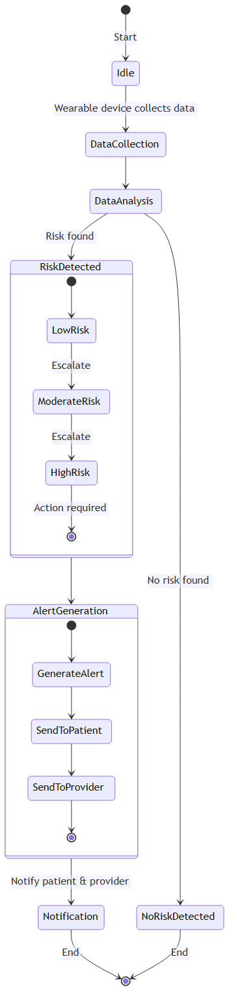

***Figure 5: UML State Diagram***

#### **States & Transitions:**

* **Idle**: The initial state before data collection starts.
* **DataCollection**: Data is collected from the wearable device.
* **DataAnalysis**: Collected data is analyzed for potential risks.
* **RiskDetected**: If a risk is detected, the process moves into risk levels:
  + **LowRisk** transitions to **ModerateRisk**,
  + **ModerateRisk** escalates to **HighRisk**,
  + **HighRisk** requires immediate action.
* **AlertGeneration**: Alert is generated and then sent to the patient and healthcare provider.
* **Notification**: Patients and providers are notified, concluding the alert process.
* **NoRiskDetected**: If no risk is detected, the process ends.

The UML State Diagram provides a detailed visualization of the various states and transitions within the healthcare monitoring system. It starts in an "Idle" state before any data collection begins. When data collection is initiated, it transitions to the "DataCollection" state, where data is gathered from wearable devices. This is followed by the "DataAnalysis" state, where the collected data is analyzed for potential risks. If a risk is detected, the system transitions through various risk levels: from "LowRisk" to "ModerateRisk," and if necessary, to "HighRisk," which requires immediate action. Alerts are then generated and sent to patients and healthcare providers in the "AlertGeneration" state, followed by notifications in the "Notification" state. If no risks are found, the system returns to the "NoRiskDetected" state, marking the end of the process. This diagram effectively captures the dynamic nature of the system as it processes health data and responds to potential health threats.

### **UML Activity Diagram (Swimlane Diagram)**

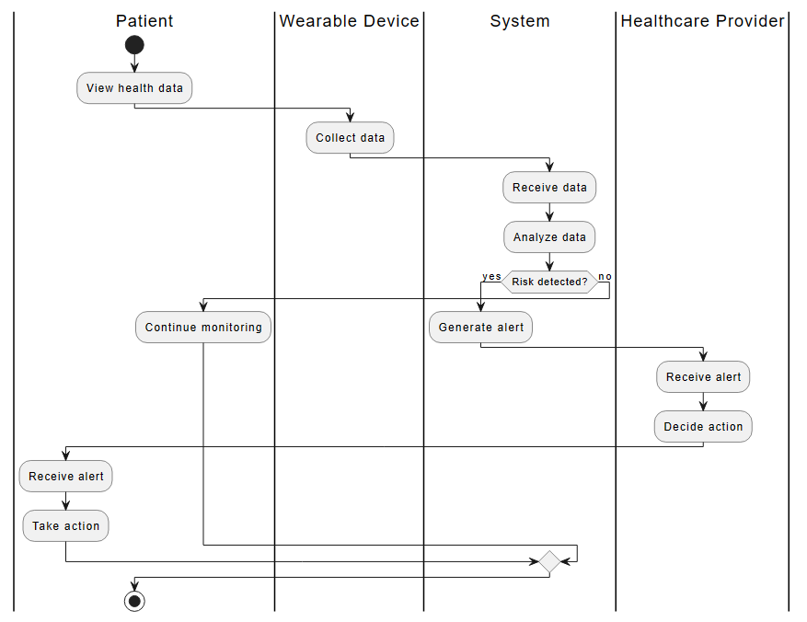

***Figure 6: UML Activity Diagram***

#### **Swimlane Overview:**

* **Patient**: Begins by viewing health data.
* **Wearable Device**: Collects health data and sends it to the system.
* **System**: Receives and analyzes the data. If a risk is detected, it generates an alert.
* **Healthcare Provider**: Receives the alert, decides on the necessary action.
* **Patient**: Receives the alert and takes action based on the provided recommendations.

The UML Activity Diagram (Swimlane Diagram) provides the responsibilities and actions of different actors within the healthcare monitoring system across parallel "swimlanes." Each lane represents a different actor or component of the system, such as the Patient, Wearable Device, System, and Healthcare Provider. The process begins with the Patient viewing their health data. Concurrently, the Wearable Device collects health data and sends it to the System. The System analyzes this data and, if a risk is detected, generates an alert. This alert is then received by both the Healthcare Provider, who decides on the necessary action, and the Patient, who takes action based on the recommendations provided. This swimlane diagram illustrates the flow of activities and the interaction between different system components from data collection to the management of alerts.

### **UML Component Diagram**

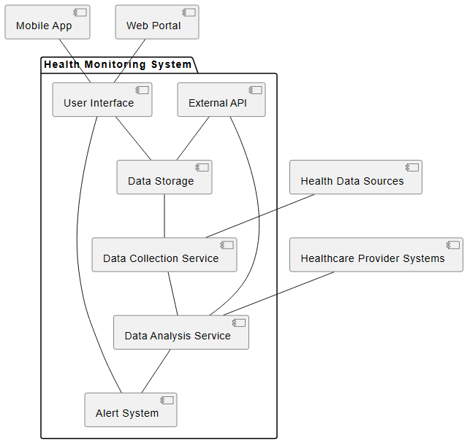

***Figure 7: UML Component Diagram***

#### **System Components and Their Dependencies:**

* **Data Collection Service**: Gathers data from health data sources.
* **Data Storage**: Stores the collected data and supports data access for the user interface.
* **Data Analysis Service**: Analyzes the data collected and interacts with external APIs for additional functionality; it also feeds data to the alert system.
* **Alert System**: Generates alerts based on analysis results and communicates them through the user interface.
* **User Interface**: Provides an interface for both the mobile app and web portal, allowing user interaction with stored data and alerts.
* **External API**: Integrates external health and data services for enriched data analysis and storage capabilities.
* **Mobile App & Web Portal**: Allows end-users to access their health data and receive alerts.
* **Healthcare Provider Systems**: Provides additional data to the Data Analysis Service for comprehensive analysis.

The component diagram of the Healthcare Monitoring System illustrates the system's architecture, emphasizing the interaction between various software components. Data is collected by the Data Collection Service from various health data sources and stored in the Data Storage component. The Data Analysis Service processes this data and, based on the analysis, the Alert System generates notifications for patients and healthcare providers through the User Interface. External APIs enhance the system's capabilities by providing additional data integration and analysis options, interfacing with both the Data Analysis Service and Data Storage.

### **Cloud Deployment Diagram**

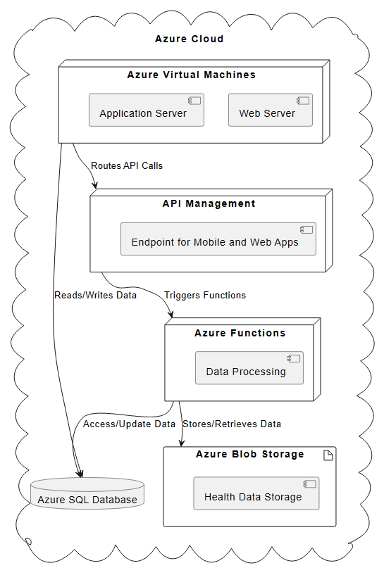

***Figure 8: Cloud Deployment Diagram***

#### **Azure Deployment Overview:**

* **Azure Virtual Machines**: Host both the web and application servers, handling the core processing and user interactions.
* **Azure SQL Database**: Provides the relational database services for storing and managing structured data effectively.
* **Azure Functions**: Serverless computing service that manages data processing tasks, enhancing scalability and responsiveness.
* **Azure Blob Storage**: Used for large-scale health data storage, ensuring data durability and high availability.
* **API Management**: Facilitates secure and efficient API exposure to mobile and web applications, managing traffic and authorization.

The cloud deployment diagram for the Healthcare Monitoring System on Microsoft Azure outlines the integration of various Azure services to support system operations. Azure Virtual Machines are utilized to host the web and application servers, managing the processing and interaction layers of the system. Data handling and storage are facilitated through Azure SQL Database and Azure Blob Storage, ensuring robust data management and scalability. Azure Functions provide serverless computing capabilities for efficient data processing, while Azure API Management governs the secure access and management of APIs for mobile and web applications.

### **Skeleton Classes & Tables Definition**

**Basic Outlines of the Main Classes**

The outlines of the main classes involved in the Healthcare Monitoring System along with their attributes and methods. This will include classes such as **Patient**, **HealthData**, **WearableDevice**, **HealthcareProvider**, **Alert, and System**. Additionally, I'll include the main tables that could correspond to these classes for database storage purposes.



***Table 1: Basic outlines of the Main Classes***

**Define the Structure to Store System Data**

To ensure the Healthcare Monitoring System functions efficiently, it important to define the structure of the database tables required to store system data comprehensively. The table will be designed to store all necessary details about patients, health data, wearable devices, healthcare providers, and alerts generated by the system.



***Table 2: Structure of Database That Required to Store System Data***

**Design Patterns**  
To enhance the design of the Healthcare Monitoring System, implementing well-established design patterns and best practices can significantly improve both the system's architecture and its maintainability. Here's an explanation of several design patterns from different categories (GRASP, SOLID, GoF, and Microservices) that could be implemented in the system, along with justifications for their use:

**1. GRASP (General Responsibility Assignment Software Patterns)**

**Controller Pattern:** The system uses controllers to handle incoming requests, managing the flow between the user interface and system operations. For example, in the alert generation process, a controller could manage the interaction from receiving data from wearable devices to triggering alerts in the system. This pattern helps in reducing the complexity of the user interface by delegating control logic to specific controllers, enhancing modularity and maintainability.

**2. SOLID Principles**

**Single Responsibility Principle (SRP):** Each class in the system has a single responsibility. For instance, the *HealthData* class is solely responsible for managing health data storage and retrieval, not the logic for analyzing the data or generating alerts. This principal aids in making the system easier to understand, maintain, and extend.

**Open/Closed Principle (OCP):** The system's design allows classes to be open for extension but closed for modification. For example, adding new types of analyses or data processors without altering existing code can be achieved by extending base classes or interfaces. This flexibility is crucial for adapting to new types of wearable devices or data formats.

**3. GoF (Gang of Four) Patterns**

**Factory Method Pattern:** Used for creating objects in the system without specifying the exact class of object that will be created. This is particularly useful for the creation of different types of alerts or reports based on varying thresholds or data types, enabling the system to scale and adapt to new requirements dynamically.

**Observer Pattern:** This pattern is suitable for the alert system where the subject (health data monitor) notifies multiple observers (patients, healthcare providers) about significant health data changes. It promotes a robust and flexible communication mechanism between the system and its users.

**4. Microservices Design Patterns**

**API Gateway Pattern:** Serves as a single-entry point for all client requests to the backend services, which is ideal for handling requests from both the mobile app and web portal in the system. This pattern simplifies client-side communications and provides a centralized point for security, load balancing, and caching.

**Database per Service:** Each microservice (like data collection, data analysis, user management) owns its database, enhancing the system's resilience and ensuring that database failures affect only a single service rather than the entire system.

**Best Practices**

**Continuous Integration/Continuous Deployment (CI/CD):** Automates the testing and deployment processes, ensuring that changes are systematically validated and deployed to production with minimal downtime.

**Containerization (using Docker or Kubernetes):** Helps in deploying each microservice in its container, which simplifies dependencies management, scales services independently, and improves the overall reliability and reproducibility of the environment.

**Justification**

Implementing these design patterns and best practices in the Healthcare Monitoring System ensures that the architecture is not only robust and scalable but also flexible enough to accommodate future changes and integrations. These patterns help manage complexity by encouraging modularity, ensuring that components are loosely coupled and highly cohesive, which is crucial for long-term maintenance and scalability. The use of microservices, along with their associated patterns, further enhances the system's ability to operate reliably at scale, which is essential given the potential size and scope of data and user interactions involved.

Top of Form